Edition: September 01, 2025

___
Includes Physics, Math, and Python Programming.
A monthly copy of highschool exams by: Joseph Gachau.


SPACE MATH / PHYSICS: [1 hr 30 min]

Questions

Section 1:
1. If a rocket travels at 5 km/s, how far will it travel in 10 seconds?
2. A satellite orbits Earth at 7.8 km/s. How many kilometers does it travel in 1 minute?
3. The Moon is approximately 384,400 km from Earth. How many hours would it take a spaceship traveling at 10,000 km/h to reach the Moon?
4. A star is 4 light-years away. If 1 light-year is about 9.46 trillion km, what is the distance in kilometers?
5. If a planet has a diameter of 12,742 km, what is its radius?
6. A space probe sends data at a rate of 2 MB per second. How much data is sent in 5 seconds?
7. If Mars is 78 million km from Earth, how many minutes would it take for a signal traveling at 300,000 km/s to reach Mars?
8. A rocket carries 500 kg of fuel. If it uses 25 kg per minute, how long can it operate?
9. If an asteroid travels 15 km/s, how far does it travel in 2 hours?
10. The Sun’s diameter is about 1.39 million km. If a model scales it down to 1 cm, what is the scale factor?
11. A space station orbits Earth every 90 minutes. How many orbits does it complete in 24 hours?
12. If a planet’s orbit has a circumference of 942 million km, what is the radius of the orbit? (Use π ≈ 3.14)
13. A spacecraft travels 100,000 km in 5 hours. What is its average speed in km/h?
14. If a comet’s tail is 10 million km long, how long is it in meters?
15. A telescope observes a star for 3 hours. If it records 2 images per minute, how many images are recorded?
16. If a rocket’s fuel tank holds 1,000 liters and it uses 50 liters per second, how long will the fuel last?
17. The distance to Jupiter is 588 million km. How many days would it take to travel there at 20,000 km/h?
18. If a space probe weighs 2,000 kg on Earth, what is its weight in pounds? (1 kg ≈ 2.2 lbs)
19. A satellite travels 36,000 km in one orbit. How far does it travel in 5 orbits?
20. If a star’s light takes 8 years to reach Earth, and the speed of light is 300,000 km/s, how far is the star in kilometers?
21. A spacecraft uses 10 liters of fuel per minute. How much fuel is used in 15 minutes?
22. If a planet is 150 million km from the Sun, how long does it take for sunlight to reach it at 300,000 km/s?
23. A rocket accelerates at 2 m/s² for 10 seconds. What is its final speed if it starts from rest?
24. If an asteroid has a mass of 1,000 kg and is split into 4 equal parts, what is the mass of each part?
25. A space probe travels 1,000,000 km in 10 days. What is its average speed in km/day?

Section 2:

26. The Earth is about 150 million km from the Sun. Light travels at 300,000 km/s. How many minutes does it take sunlight to reach Earth?
27. A spacecraft is orbiting Earth at an altitude of 400 km. If Earth’s radius is about 6,371 km, what is the orbital radius of the spacecraft?
28. Jupiter is about 5.2 AU from the Sun. If 1 AU ≈ 150 million km, what is Jupiter’s distance from the Sun in kilometers?
29. A day on Mars is 24.6 hours. How many Earth minutes longer is this than a 24-hour Earth day?
30. The Moon orbits Earth in about 27.3 days. How many hours is this?
31. Saturn completes one orbit around the Sun in about 29.5 Earth years. How many Earth days is that (approximate, assuming 365 days per year)?
32. If an astronaut weighs 70 kg on Earth, what would be their weight on Mars, where gravity is about 0.38 g?
33. The Milky Way galaxy is about 100,000 light-years across. How many kilometers is that, if 1 light-year ≈ 9.46 × 10¹² km?
34. A satellite completes an orbit of Earth every 90 minutes. How many orbits does it make in 24 hours?
35. The Sun is about 4.3 light-years away from Alpha Centauri. In kilometers, how far is this? (1 light-year = 9.46 × 10¹² km).
36. If Earth’s circumference is 40,075 km, how fast (in km/h) is a point on the equator moving due to rotation in 24 hours?
37. Neptune takes 165 Earth years to orbit the Sun. How many Earth days is that?
38. If the surface gravity on the Moon is about 1/6 of Earth’s, how much would a 60 kg person weigh on the Moon?
39. If a spacecraft travels at 50,000 km/h, how long (in hours) would it take to travel from Earth to Mars when Mars is 225 million km away?
40. A pulsar rotates 30 times per second. How many times does it rotate in 1 hour?

Answers

Section 1:

1. 50 km
2. 468 km
3. 38.44 hours
4. 37.84 trillion km
5. 6,371 km
6. 10 MB
7. 4.33 minutes
8. 20 minutes
9. 108,000 km
10. 1:139,000,000
11. 16 orbits
12. 150 million km
13. 20,000 km/h
14. 10,000,000,000 meters
15. 360 images
16. 20 seconds
17. 1,225 days
18. 4,400 lbs
19. 180,000 km
20. 7.57 × 10^13 km
21. 150 liters
22. 500 seconds
23. 20 m/s
24. 250 kg
25. 100,000 km/day

Section 2:

26. 8.3 minutes
27. 6,771 km
28. 780 million km
29. 36 minutes
30. 655.2 hours
31. 10,768 days
32. 26.6 kg (weight equivalent)
33. 9.46 × 10¹⁷ km
34. 16 orbits
35. 4.07 × 10¹³ km
36. 1,670 km/h
37. 60,225 days
38. 10 kg (weight equivalent)
39. 4,500 hours
40. 108,000 rotations

MATH: (Paper 1) [2 hrs 30 min]

Questions

Section 1:

1. Solve for x: 2x + 5 = 17
2. Simplify: (3x^2y)(4xy^3)
3. What is the slope of the line passing through points (2, 3) and (5, 9)?
4. Factorize completely: x^2 - 9
5. Solve the system: 2x + y = 8, x - y = 1
6. What is the value of sin(30°)?
7. Find the domain of the function f(x) = 1/(x - 2)
8. Simplify: √(50) + √(18)
9. What is the midpoint of the line segment joining (1, 4) and (7, 2)?
10. Solve for x: |x - 3| = 5
11. If f(x) = 2x + 1, find f(3)
12. What is the area of a circle with radius 4 cm? (Use π ≈ 3.14)
13. Solve: 3(x - 4) = 2x + 1
14. Find the vertex of the parabola y = x^2 - 4x + 3
15. Simplify: (2x + 3)^2
16. What is the value of cos(60°)?
17. Solve for x: log₂(x) = 3
18. Find the distance between points (1, 1) and (4, 5)
19. What is the sum of the interior angles of a pentagon?
20. Simplify: 5/(x - 1) + 2/(x - 1)
21. Solve the quadratic equation: x^2 - 5x + 6 = 0
22. What is the slope-intercept form of the line 3x - 2y = 6?
23. If a triangle has sides 3, 4, and 5 cm, what type of triangle is it?
24. Evaluate: 2^3 * 3^2
25. Find the range of the function f(x) = x^2 for x ∈ [-2, 2]
26. Solve: 4x - 7 < 9
27. What is the circumference of a circle with diameter 10 cm? (Use π ≈ 3.14)
28. Simplify: (x^2 - 4)/(x - 2)
29. Find the value of x: 2^x = 8
30. What is the area of a rectangle with length 8 cm and width 5 cm?
31. Solve for x: 2sin(x) = 1, 0 ≤ x < 2π
32. Find the equation of the line parallel to y = 2x + 1 passing through (0, 3)
33. Simplify: (8x^3y^2)/(2xy)
34. What is the volume of a cube with edge length 3 cm?
35. Solve for x: x/3 + 4 = 7

Section 2:

36. A rectangular garden has a length that is 5 meters longer than its width. If the perimeter is 34 meters, find the dimensions of the garden.
37. Construct a triangle ABC with AB = 6 cm, BC = 8 cm, and angle B = 60°. Calculate the length of side AC using the Law of Cosines.
38. Solve the system of equations: 3x - 2y + z = 7, x + y - z = 0, 2x + y + 2z = 13
39. A car travels 120 km at a constant speed. If the speed had been 10 km/h faster, the trip would have taken 1 hour less. Find the original speed.
40. Construct a square with side length 5 cm. Calculate its area and the length of its diagonal.
41. Find the equation of the circle with center (2, -3) and radius 4. Then, determine if the point (5, 0) lies on the circle.
42. A quadratic function f(x) = ax^2 + bx + c has roots x = 2 and x = -3, and f(0) = 6. Find the coefficients a, b, and c.
43. Construct an equilateral triangle with side length 6 cm. Calculate its area using the formula A = (√3/4)s^2.
44. A boat travels 20 km upstream in 4 hours and 20 km downstream in 2 hours. Find the speed of the boat in still water and the speed of the current.
45. Prove that the diagonals of a parallelogram bisect each other using coordinate geometry. Place vertices at (0, 0), (a, 0), (b, c), and (a + b, c).
46. A right triangle has a hypotenuse of 13 cm and one leg of 5 cm. Find the length of the other leg and the area of the triangle.
47. Construct a circle with radius 4 cm. Inscribe an equilateral triangle in the circle and calculate the side length of the triangle.
48. A store offers a 20% discount on an item originally priced at $50. If a 5% sales tax is applied after the discount, find the final price.
49. Two trains leave stations 300 km apart at the same time, traveling toward each other. One travels at 70 km/h, the other at 80 km/h. When do they meet?
50. Construct a rectangle with length 8 cm and width 6 cm. Calculate the length of the diagonal and the angle between the diagonal and the length.

Answers

Section 1:

1. 6
2. 12x^3y^4
3. 2
4. (x - 3)(x + 3)
5. (3, 2)
6. 1/2
7. All real numbers except x = 2
8. 8√2
9. (4, 3)
10. 8, -2
11. 7
12. 50.24 cm²
13. 13
14. (2, -1)
15. 4x^2 + 12x + 9
16. 1/2
17. 8
18. 5
19. 540°
20. 7/(x - 1)
21. 2, 3
22. y = (3/2)x - 3
23. Right triangle
24. 72
25. [0, 4]
26. x < 4
27. 31.4 cm
28. x + 2
29. 3
30. 40 cm²
31. π/6, 5π/6
32. y = 2x + 3
33. 4x^2y
34. 27 cm³
35. 9

Section 2:

36. Width = 6 m, Length = 11 m
37. 7.21 cm
38. (2, 1, -1)
39. 60 km/h
40. Area = 25 cm², Diagonal = 5√2 cm
41. (x - 2)^2 + (y + 3)^2 = 16, Yes
42. a = 1, b = 1, c = 6
43. 15.59 cm²
44. Boat speed = 7.5 km/h, Current speed = 2.5 km/h
45. Midpoints of diagonals are (a/2 + b/2, c/2)
46. Other leg = 12 cm, Area = 30 cm²
47. Side length = 6.93 cm
48. $42
49. 2 hours
50. Diagonal = 10 cm, Angle ≈ 36.87°

MATH & PYTHON: (Paper 2) [2hrs 45 min]

Questions

Section 1:

1. Solve for x: 2x^3 - 8x = 0
2. Find the inverse of the function f(x) = 2x + 3
3. Determine the value of sin(π/3) + cos(π/6)
4. Solve the system: 2x + y - z = 1, x - y + 2z = 4, 3x + 2y - z = 5
5. Find the limit: lim (x→2) (x^2 - 4)/(x - 2)
6. Calculate the area of a triangle with vertices at (0, 0), (3, 0), and (0, 4)
7. Solve for x: log₂(x) + log₂(x - 1) = 1
8. Find the equation of the tangent line to y = x^2 at x = 1
9. Determine the sum of the infinite geometric series: 1 + 1/3 + 1/9 + ...
10. Solve the inequality: |2x - 3| < 5
11. Find the vertex of the parabola y = 2x^2 - 8x + 5
12. Evaluate: ∫ (from 0 to 1) (2x + 1) dx
13. Find the polar coordinates of the point (3, 3√3)
14. Solve for x: e^(2x) - 3e^x + 2 = 0
15. Determine the number of real roots of x^4 - 5x^2 + 4 = 0
16. Find the angle between vectors u = (1, 2) and v = (3, -1)
17. Simplify: (1 + i)^3, where i is the imaginary unit
18. Find the area of a circle inscribed in a square with side length 8 cm
19. Solve the trigonometric equation: 2sin^2(x) - sin(x) - 1 = 0, 0 ≤ x < 2π
20. Find the sum of the first 10 terms of the arithmetic sequence with a₁ = 3, d = 4
21. Determine the domain of f(x) = ln(x^2 - 4)
22. Find the probability of drawing 2 aces from a standard deck of 52 cards without replacement
23. Solve for x: 3^(2x) = 27
24. Find the equation of the circle with center (1, -2) passing through (4, 2)
25. Calculate the volume of a sphere with radius 3 cm (Use π ≈ 3.14)
26. Find the derivative of f(x) = x^3 - 3x + 2
27. Solve the system: x^2 + y = 5, x + y = 3
28. Determine the eccentricity of the ellipse 4x^2 + 9y^2 = 36
29. Find the sum of the series: Σ (n=1 to 5) (2n + 1)
30. Solve for x: cos(2x) = 1/2, 0 ≤ x < 2π
31. Find the distance from the point (2, 3) to the line 3x - 4y + 12 = 0
32. Simplify: (x^2 - 1)/(x - 1) - (x + 1)
33. Find the roots of the quadratic equation 2x^2 - 4x - 3 = 0
34. Determine the period of the function f(x) = 3sin(2x) + 1
35. Find the matrix product AB where A = [[1, 2], [3, 4]] and B = [[0, 1], [1, 0]]

Section 2:

36. Write a Python expression to calculate 5 + 3 * 2
37. Write a Python statement to assign the value 10 to a variable x
38. Write a Python expression to find the square of 7
39. Write a Python code snippet to print the value of π (use math.pi)
40. Write a Python expression to calculate the area of a rectangle with length 6 and width 4
41. Write a Python code snippet to check if 15 is divisible by 3
42. Write a Python expression to evaluate (2^3) + 5
43. Write a Python code snippet to find the absolute value of -10
44. Write a Python expression to calculate the average of 4, 8, and 12
45. Write a Python code snippet to convert 25°C to Fahrenheit (F = C * 9/5 + 32)
46. Write a Python expression to calculate the perimeter of a square with side length 5
47. Write a Python code snippet to find the maximum of 3, 7, and 2
48. Write a Python expression to evaluate 10 modulo 3
49. Write a Python code snippet to calculate the area of a circle with radius 5 (use math.pi)
50. Write a Python code snippet to check if a variable x = 8 is even

Answers

Section 1:

1. 0, 2, -2
2. f^(-1)(x) = (x - 3)/2
3. √3
4. (1, 2, 3)
5. 4
6. 6 square units
7. 2
8. y = 2x - 1
9. 3/2
10. -1 < x < 4
11. (2, -3)
12. 2
13. (6, π/3)
14. 0, ln(2)
15. 4
16. ≈ 56.31°
17. -2 + 2i
18. 16π cm²
19. π/6, 5π/6
20. 210
21. x < -2 or x > 2
22. 1/221
23. 3/2
24. (x - 1)^2 + (y + 2)^2 = 25
25. 113.04 cm³
26. 3x^2 - 3
27. (1, 2), (2, 1)
28. √5/3
29. 30
30. π/6, 5π/6
31. 5
32. x - 2
33. (2 ± √10)/2
34. π
35. [[2, 1], [4, 3]]

Section 2:

36. 11
37. x = 10
38. 49
39. import math; print(math.pi)
40. 24
41. if 15 % 3 == 0: print("Divisible")
42. 13
43. print(abs(-10))
44. 8
45. f = 25 * 9/5 + 32; print(f)
46. 20
47. print(max(3, 7, 2))
48. 1
49. import math; print(math.pi * 5**2)
50. if 8 % 2 == 0: print("Even")

ARTWORKS:

Joe Adix - Gyrocopter


Joe Adix - A Black Gollum


The Duke of Artz - Cheetahs
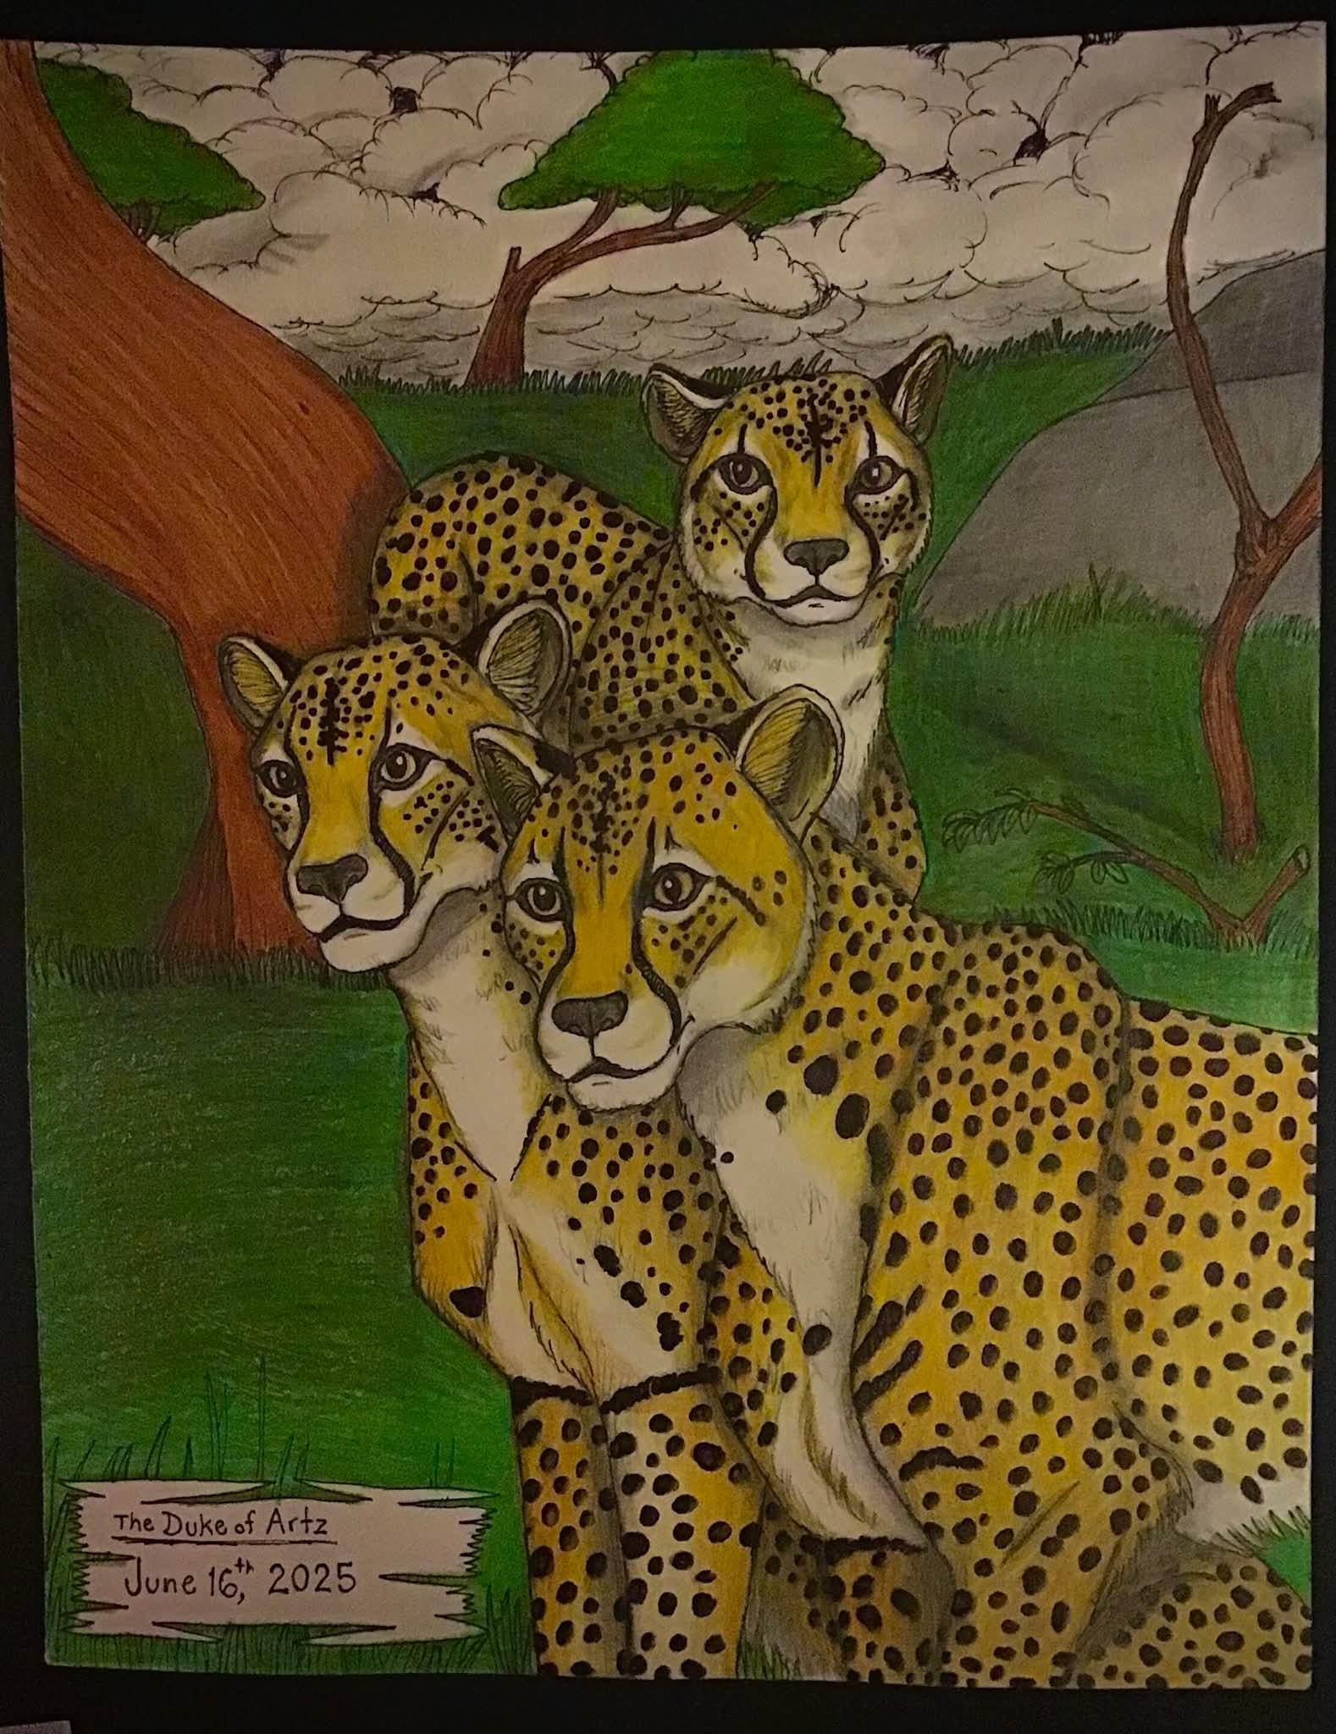

The Duke of Artz - The Gray Werewolf
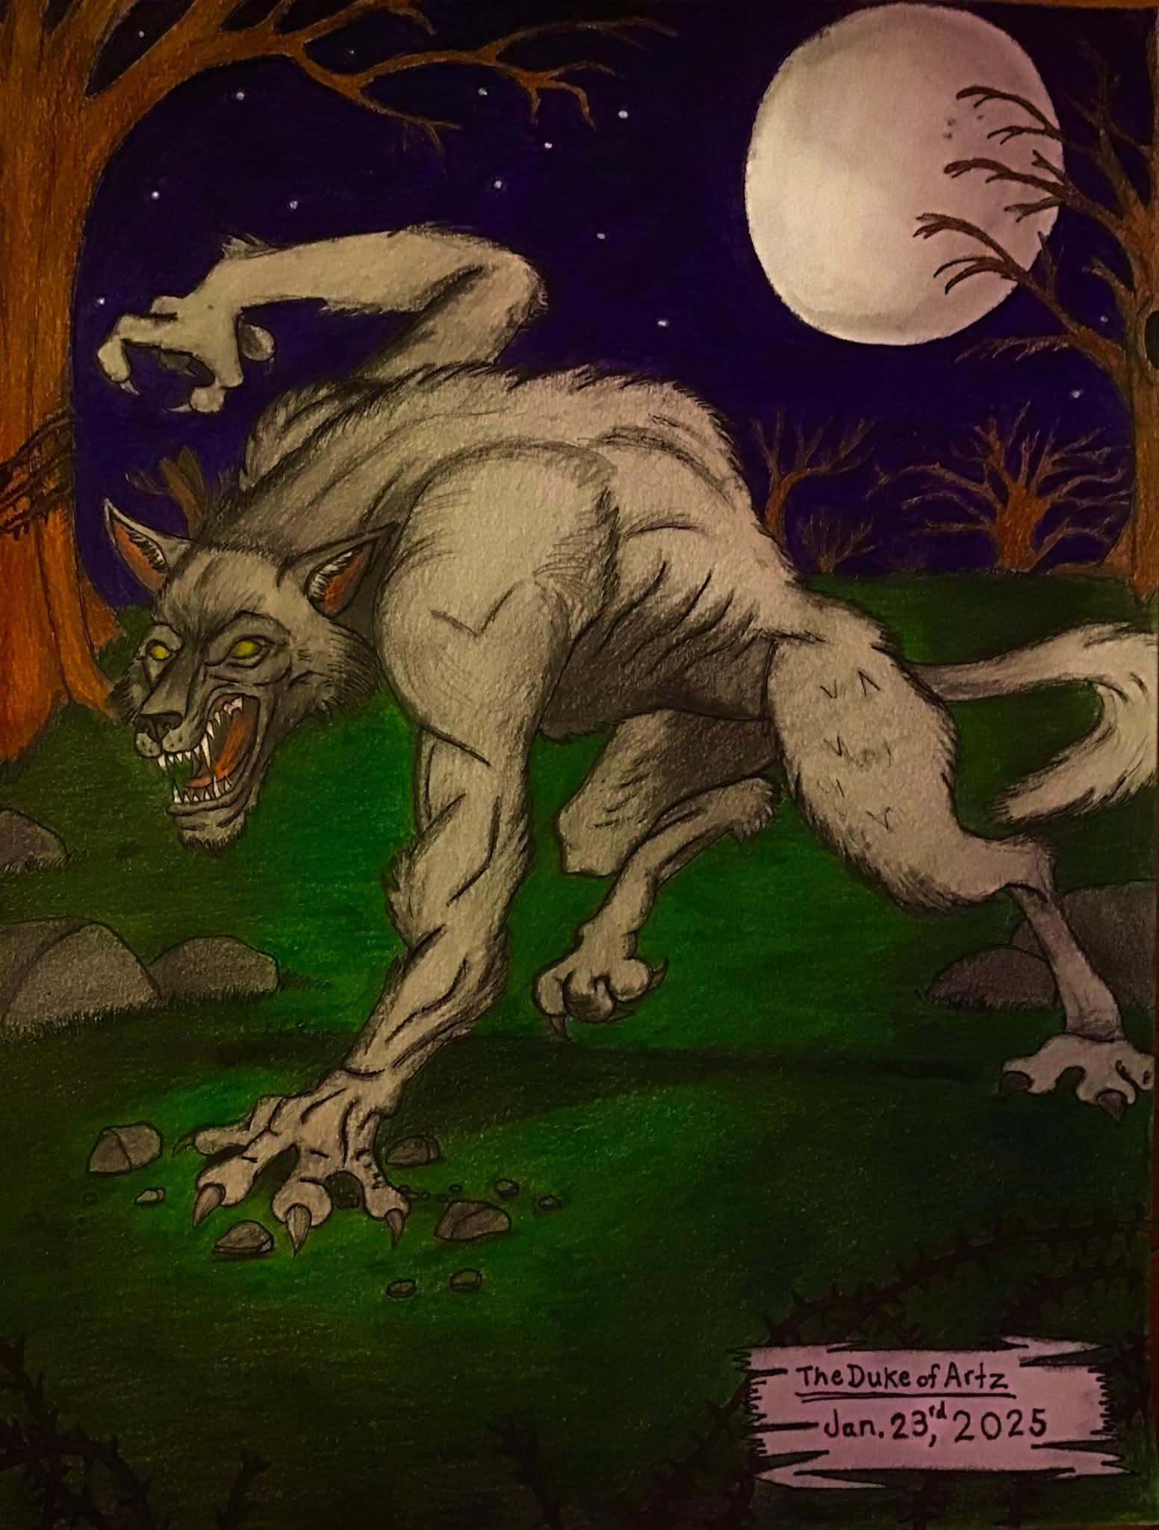

This magazine is not for sale.
It's supported by worldwide voluntary donations and collaborators for the sake of the Autism Spectrum Disorder (ASD) activism course.



Scan the QR Code above in order to download this magazine and read it offline using your phone.
Or visit: www.joeadix.art.blog
WhatsApp No. : 0110010043

