Edition: June 01, 2025
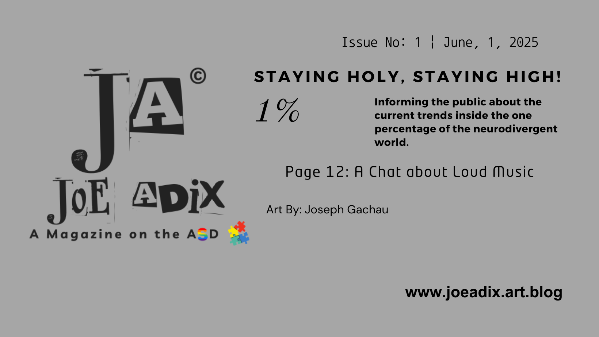
___
Includes Autistic stories, Artworks, and Poems/Tweets.
Written and compiled by: Joseph Gachau.


ARTICLES:

Did the Boy Mentioned in Matthew 17 Have Autism?

By: Joseph Gachau
In verses 14 and 15 of Matthew chapter 17, a man kneels before Jesus and asks him to heal his son who has a bad case of epilepsy. He “often falls into a fire or into water”, the man also adds.

My Google search about the occurrence of ASD (Autism Spectrum Disorder) in the Bible led me to this chapter. There is a boy mentioned in this scripture who seems to have symptoms that we could, on a lower scale, attribute to autism. In verses 14 and 15, a man kneels before Jesus and asks him to heal his son who has a bad case of epilepsy. He “often falls into a fire or into water” (Contemporary English Version), the man also adds.
Today, some experts list the case of epilepsy as a co-occurrence of autism. I may not thoroughly explain what autism (ASD) is, now, but just know that it’s a neurodivergent issue that commonly makes guys appear strange in the contemporary world. For instance some guys on the spectrum appear to want to live alone, extremely lost to anger and day-dream especially in childhood.
An important thing to note here is that not all guys who have epilepsy are autistic and the vice versa is true. Having read the verses (14 to 21) of this scripture, I guess you have perhaps identified that the boy was also said to have been possessed by a demon. This does not imply that guys who have epilepsy, ASD or both are possessed by an evil force. It goes without doubt that the behaviors of that boy appeared like those of a person dominated by a demon. We also tend to say lightly that someone has been cast a spell over if they are behaving strangely although we know that’s not the case. I think what the Bible teaches here is that these conditions individually tend to have mysterious origins and no human-led cure.

PICTURE: The boy suffering from epilepsy in the Bible. Credit: JM Drawing by AI (View page 4)

Speaking of people claiming that someone has been possessed by a demon and particularly addressing the plight of autistic people of color; there has been an ongoing and disturbing craze in Kitui regions of Kenya about residents claiming that ASD is an aftermath of someone being associated with witchcraft. There is really a demand for more people to be educated about this anomalous thing in the brain.
Having done with that story of the Bible, may I now share some of my experiences of autism related to attending Christian meetings? Here I go …
As a guy with autism and as one of Jehovah’s Witnesses, I find it challenging sometimes to attend Kingdom Halls on Sundays. As a new member, the thought that I’m going there to make new friends is somehow discouraging. Honestly I usually leave meetings a few minutes after shaking hands with fellow brothers and sisters.
Before the meetings commence, I tend to sit at the corners of the hall as a deliberate move to minimize the chances of being touched. This is tactile defensiveness (an ASD hyperactivity to touch).
However, sometimes, while sitting waiting for the meetings to start, the brothers and sisters approach me with smiling faces to introduce themselves. This positive attitude somehow alleviates the ‘pain’ of being touched. Showing love towards each other is a custom in Jehovah’s organization and I’m glad for it. You can feel the love; it’s real!
This brotherhood custom acts as an inspiration that pushes me towards attending subsequent meetings, learning, and making new friends. What I have come to learn is that: We should not let the sensory input overload of ASD keep us away from social activities that allistic people engage in!
And there you have it! I already detailed my take about the condition of the boy mentioned in that intriguing story of the holy writ. I also have briefly described my experience as an autistic individual living in the modern time. It would be my pleasure now to show you how our loving creator cared for the interests of autistic people in ancient times and how he continues to care for us on the spectrum — we who live in the current time.
To start with, I have this strong conviction that many people on the autism spectrum also like learning about the person who created the universe. The Bible is metaphysical, if I could simply describe it, and autism has been closely correlated to intense love for topics related to mysteries. It follows without doubt then that autistic people who lived in ancient times and read Apostle Paul’s letters, just to mention him as an example, enjoyed them! Perhaps those people made some notes on papyrus using feathers as pens. This must have been an exciting exercise of scribe-work since they learned more by writing down notes. Every person today who learns not only by reading but also writing down notes will attest that doing this is fun! Hence, God cared for the joy of autistic people in the past by giving them something to learn from and the creativity to write it down.
I need not say how many learning channels people on the spectrum have today. We have access not only to the holy writ and thousands of other topics that have mystery in them but also to resources that teach us specifically about autism. ‘The Art of Autism’ website is one of the creative resources in our modern time that effectively teaches us about autism since we get to learn directly from bloggers like me who have had lived-experiences of this neurodivergence. This is tangible evidence that our creator continues to care for our knowledge needs and our joy.


6 Ways Realising I Was Autistic Saved My Life…
By: Louise Chandler
1. It gave me permission to deny the neurotypical norms which no longer served me.
Once I realised I was autistic it gave me permission to no longer hold onto certain neurotypical norms that no longer served me.
For example, the neurotypical norm of eating a variety of food that is seen as 'grown up' or socially acceptable. I learnt to no longer disregard my own preferences and needs around food to please other people or society. If it is right for me to eat the same food each day, that is what will happen.
2. It gave me language and understanding of my own brain.
It gave me the language and understanding of my autistic brain. It helped me to realise that I am not alone. For example, I learnt that I wasn't just being 'too sensitive' when it felt too loud or the seams of my clothes were irritating me, I was actually experiencing sensory overload. Similarly, I wasn't having a 'tantrum' or a panic attack, I was having an autistic meltdown.
3. It allowed me to deeply lean into my needs and accommodate myself.
For as long as I remember, I assumed that everyone else had, for example, the same sensory experiences as me, I was just bad at coping. However, realising I was autistic gave me the opportunity to accommodate myself and to lean into my needs.
For example, I learnt to use stim toys and noise cancelling headphones for my sensory needs. I learnt to rest when I needed to without the levels of guilt I used to feel. I could be my authentic self.
4. It gave me the understanding that my autistic traits were not character flaws.
I had for so long felt that my autistic traits were personal character flaws. I felt like a bad person and held a sense of constant guilt.
However, realising I was autistic, allowed me to realise that my executive functioning difficulties were not laziness, I was facing struggles others weren't. I realised that my special interests weren't me being obsessive'; they are valid and I am allowed to have deep and joyfully intense interests.
5. It gave me a sense of community and the sense that I wasn't alone.
Realising I was autistic, gave me a sense of community. I finally felt like I had found my place and had a sense of belonging, after a lifetime of feeling like an outsider. I related to other people's experiences and found new ways to manage autistic life.
6. It gave me hope for my future.
Before I realised I was autistic, I was in a cycle of repeated burnout and struggling heavily with my mental health. Most of all, realising I was autistic gave me hope for the future. It gave me a future where I felt that I could belong, a future where I could understand myself, accommodate my needs and deny the neurotypical norms which no longer serve me.

Actually Supporting Autistic People Involves …
By: Louise Chandler
1. Supporting us when we ask for reasonable adjustments.
Autistic people are often told that we are 'too much' or like a 'burden' when asking for reasonable adjustments or accommodations. Similarly, we are sometimes told we are being unfair or getting a 'head start'.
2. Supporting us when we are unmasked.
Sometimes, it feels like society is saying to us, it is okay to be autistic, as long as you mask. When we unmask, we are sometimes ridiculed or stared at for our visible autistic traits.
3. Supporting us if we can't work or be 'productive'.
Often, unfortunately it is only certain groups of autistic people, who are seen as valuable and that usually depends on how valuable they are or are seen to be, to capitalist society. All autistic people are valuable.
4. Believing us, even if we don't fit the stereotypes of being autistic.
Believe autistic people when they tell you that they are autistic, even if they don't fit the stereotypes of autism. Representation and general understanding of autism is quite limited within the society.
5. Supporting us if we miss social cues, not just assuming we are rude.
Supporting autistic people when we miss social cues or don't follow the norms associated with neurotypical norms. Don't just assume that we are being 'rude' or not 'trying'.
6. Not judging autistic traits, including in non autistic people.
Don't make fun of or shame autistic traits, even in neurotypical people. For example, not making fun of people with unusual or intense interests.
7. Not judging autistic people who struggle with hygiene.
Autistic people sometimes struggle with hygiene for a number of reasons and as a result, we can sometimes be shamed by others or told that we are just being lazy. Autistic people are tired of being judged, when we are struggling with hygiene.
8. Supporting autistic people who have meltdowns.
Autistic meltdowns can be really hard and they can be made even worse when we are met with judgement and shame. Autistic people deserve to be met with care and support when struggling.
9. Supporting autistic people who put in place boundaries.
Authentically supporting autistic people includes supporting autistic people when we put in place boundaries. For example, if we say 'no' to attending a social gathering or ask for emails or text messages instead of phone calls.
10. Not judging autistic people who struggle with emotional regulation.
Autistic people sometimes struggle with emotional regulation. As a result of this, we are sometimes told that we should just 'be less sensitive' or 'learn to control ourselves.'
11. Standing up for autistic people even when we aren't in the room.
Truly supporting autistic people involves supporting us and standing up for us, even if we aren't in the room. It means saying something in the face of ableism.
12. Raising awareness and acceptance of autism outside of just awareness months.
It means raising awareness and accepting autistic people all year round not just for a day or week in April. Autistic people exist all year round.

8 Ways to Ask for Adjustments Without Disclosing that you are Autistic
By: Louise Chandler
- I tend to be someone who needs and sticks to routine. It helps me to be at my best.
- I am sensitive to noise so I sometimes wear headphones in order to drown it out. I am still able to hear what you are saying.
- These lights are too bright and are hurting my eyes. Can you turn them off please.
- I am really passionate about x topic and sometimes I talk about the topic a lot. If I get distracted, feel free to re- direct me.
- I tend to be someone who needs and sticks to routine. It helps me to be at my best.
- I need a bit of time to process that. I will let you know by X date.
- I find it helpful for information to be direct and clear. I don't always pick up on subtle non-spoken cues.
- Autistic people may need things with us to help regulate ourselves and to cope. This might be special interest related items or sensory items. For autistic people, going somewhere new can be particularly anxiety provoking and difficult. Having lots of things (over-packing) with us can help us to cope.

ARTWORKS:

A Chat about Loud Music
By: Joseph Gachau
Mark: You always carry headphones with you whenever you pay a visit to my homeplace.
Paul: Yeah music helps mitigate the sensory overload caused by unexpected and unpleasant noise from crowds, motorbikes, and car horns plus other aspects of the busy street I pass through.
Mark: I understand this has to do with your autism but isn't loud music a noise by itself?
Paul: Surprisingly loud music isn't overwhelming for me. I actually enjoy the 'noise of music'.
Mark: I get it friend; I'll always have your back!
PICTURE: Mark and Paul chats at a riverbank. Credit: JM Drawing by AI (View page 13)


Hand Embroidery
By: Sabrina Zarco

PICTURE: Hand Embroidery. Credit : Sabrina Zarco (View page 14)

Tree
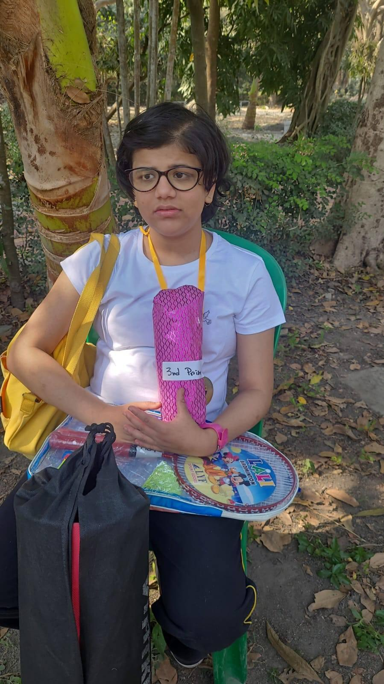By: Rajanya Kanungo
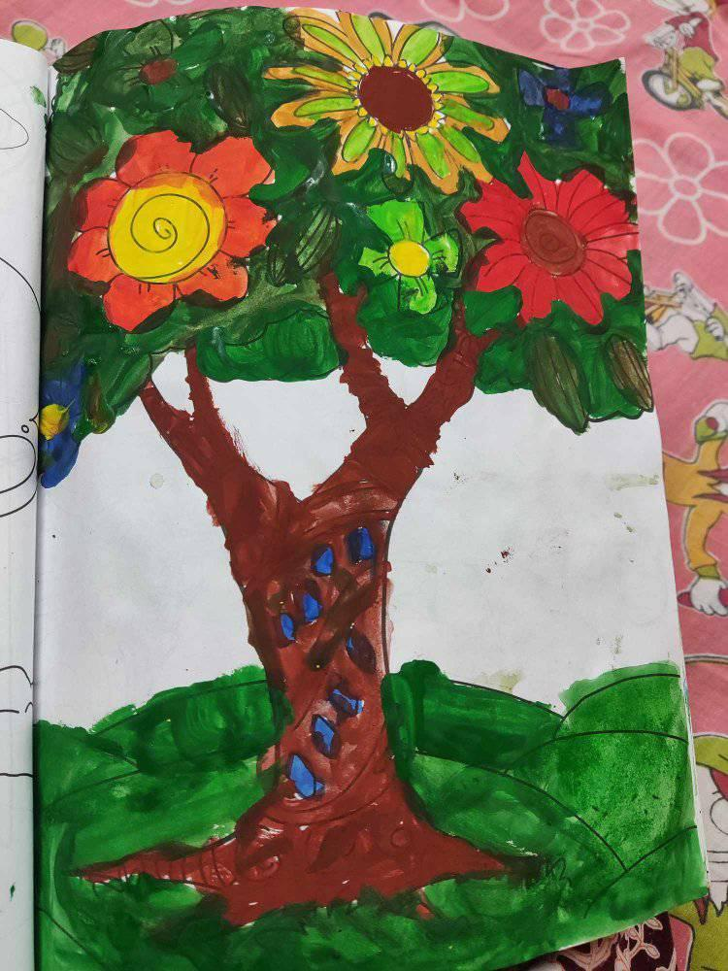
PICTURE: Tree. Credit: Rajamya Kanungo (View page 15)

Frog
By: The Duke of Artz
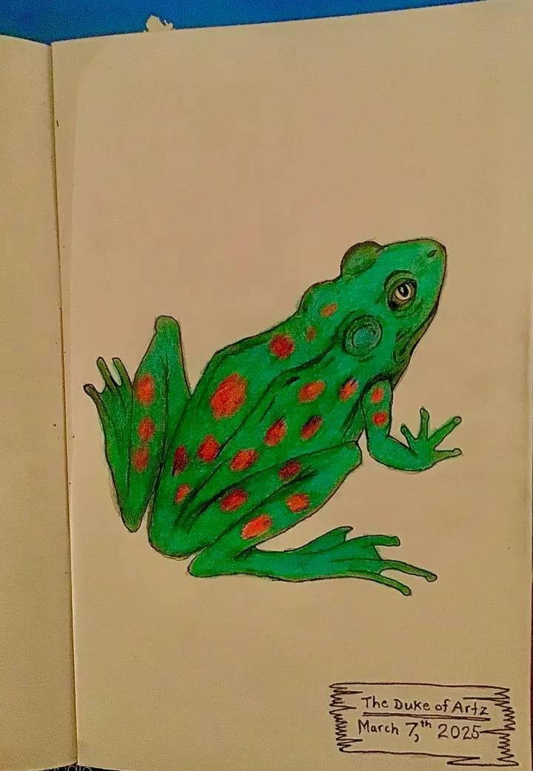
PICTURE: Frog. Credit: The Duke of Artz (View page 16)

TWEETS/CODES:

“Autistic brains generate ~42% more information at rest.”
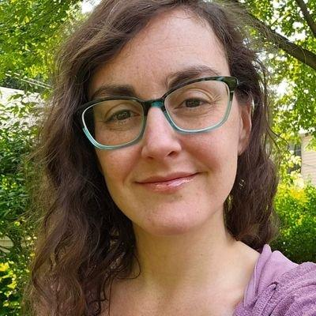
By: Nicole Filippone
Did you know that autistic brains generate ~42% more information at rest than non autistic brains, according to research? (link below)
This explains SO MUCH of the autistic experience ...
Our brains are constantly in motion.
Think about that. Even when we're not doing anything, our brains are hyperactively thinking about things. We don't get a break. I suspect this has something to do with why we are often seen as self-involved.
All humans are hard-wired to think about things that are important to them. Things that are going on in their lives... things they care about... things they have to do... things they're worried about. It's an automatic human experience. Here's the thing...
Non Autistic people get a break and can stop thinking about those things sometimes. During that break, there's room for other things. Like information about others... what's going on with them, what they care about, etc…. But not autistic people. Our brains are always on.
And having no choice in the matter, our automatic thoughts revolve around what's going on in our lives and what's important to us. So in order to take in other information, we have to focus HARD on suppressing our automatic thoughts.
Not only is this extremely difficult... it's something we need to KNOW to do in order to do it. Yet, most of us have no idea this is what's happening. So, we don't know how to initiate this intentional shift in our minds.
We CAN do it. We just need to actively think about how much we're talking about ourselves and our stuff as compared to the other person. In every single conversation. And then adjust what we are sharing based on what we HOPE will create an equal balance.
Which is HARD. And EXHAUSTING. But it is possible.
Now... whenever I post things like this, I get lots of comments telling me that the explanation doesn't remove the impact we are having on others. So, I'll address that before the comments start flowing in.
This post is not meant to suggest that autistic people shouldn't make the effort.
It's meant to explain that...
1. It IS a HUGE effort. So please cut us a little slack, and …
2. We're no more self-involved than anyone else. We just don't get a break from our own thoughts.

The 3 Reasons I used to Drink Alcohol as an Autistic Person.
By: Nicole Filippone
Today is exactly 1 year since I stopped drinking alcohol. Which is pretty huge. So in honor of this milestone...
I'm going to share the 3 reasons I used to drink as an autistic person... the reason I chose to stop... and why I'll never drink again.
Here goes …
- The main reason I used to drink was to quiet my mind. As an autistic person, my brain feels like it's constantly "on." Alcohol would slow it down, and I would get a break from my own thoughts. (The brain feeling like it's always "on" is a common autistic experience)
- To dull my senses. I have extremely intense sensory sensitivities and alcohol would make them feel more tolerable.
- To feel more comfortable and less anxious at social events. Especially ones with a lot of people. Especially if I knew almost no one there.
Now here's the reason I chose to stop drinking…
I realized that I wasn't enjoying the experience of drinking anymore. This wasn't always the case. When I started drinking in my 20s, I did enjoy it... but the last year I was drinking, 90% of my experience was pretty awful actually.
Mainly because from the moment I took my first drink, my mind would immediately fixate on how I could get my next one. Because I knew it was only a matter of time before the feelings of quiet and dulled senses wore off. And all I could think about was making sure it didn't.
And then there was the in between drinking times. I had pretty strict rules for myself when it came to drinking. Never during the day, which meant before 5... and never if I knew I needed to drive.
So during those times, my brain was constantly thinking about when I'd be able to have my next drink and "relax" again. Some people call this alcohol noise. And towards the end of my drinking, the noise was constant.
So by the end, there was truly no enjoyment in it for me anymore. Not even a little bit. Which is why I will never drink again. Because the noise, the mental fixation, was actually much worse than the 3 problems I was trying to solve with it.
I sincerely hope this helps some of you. This is an important topic, especially in the space of neurodivergence and autism awareness, because there's a significant correlation between neurodivergence and alcohol use as a coping mechanism.
I'll link to a study below that talks about this correlation. Let me know if you'd like me to do a follow up post digging into the research a bit. In the meantime... Please celebrate this milestone with me... I'm super proud of it.
Link to research for reference ...
https://pmc.ncbi.nlm.nih.gov/articles/PMC11736162/

This magazine is not for sale.
It's supported by worldwide voluntary donations and collaborators for the sake of the Autism Spectrum Disorder (ASD) activism course.

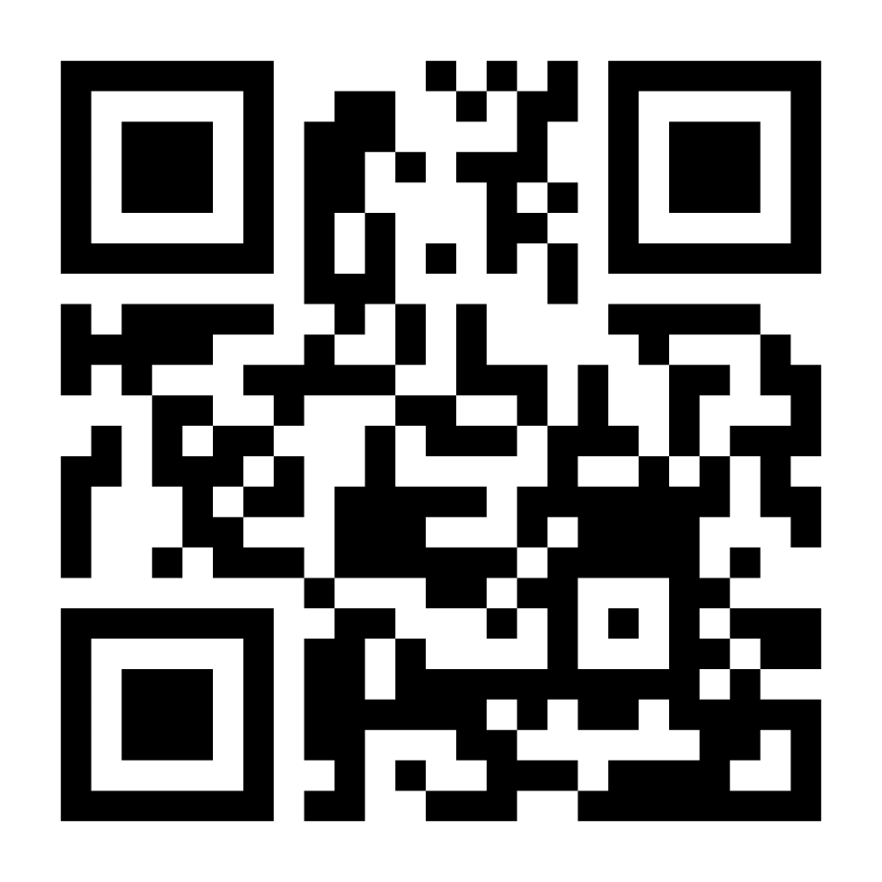

Scan the QR Code above in order to download this magazine and read it offline using your phone.
Or visit: www.joeadix.art.blog
WhatsApp No. : 0110010043

Footnotes (mobile):

According to ‘Above & Beyond Therapy’: Children with autism who have tactile defensiveness may exhibit adverse reactions such as clinging (to loved ones), complaining, lashing out (hitting out someone), or running away when confronted with touch stimuli. These emotional responses can interfere with their daily activities and social interactions, affecting their overall well-being.

